Conservation of a severely damaged Ibis mummy
By
Venice Ibrahim
I n the processes of conservation and restoration of any given piece of Archaeological heritage it is important to gather a lot of data about the given object concerning its history, identity, nature, etc., thus helping and completing work execution in well explained, simple, clear and well understood method.
The species of the birdlife found in Egypt includes 487 species of birds of which 13 are classified as globally threatened species, and 3 identified as being introduced to Egypt. ¹

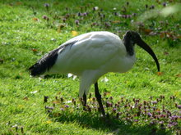 Sacred ibis

The ibises are a group of long-legged a heron like wading birds in the family Threskiornithidae feed as a group, probing mud for food items, usually crustaceans. There are 14 Genera with 26 species constituting the subfamily Threskiornithinae of the family Threskiornithidae (order Ciconiiformes), which also includes the spoonbills. There length varies from about 55 to 75 cm. Ibises inhabit warm regions around the world, some of them visiting colder latitudes in summer. Some are white, with colored heads, legs, and tails; others have variously colored plumage. Their necks, legs, and down-curving bills are long, their tails are short, they build nests of sticks on the ground or in trees or bushes. The female lays three to five greenish or bluish eggs, sometimes spotted with brown. Both parents tend the eggs and young. ²

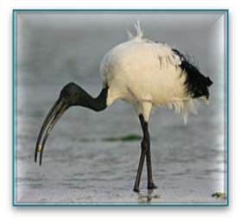

Birds fascinated ancient Egyptians with their beauty, power and flying ability and this is clear where some of their writing letters Hieroglyphs were depictions of.³
The ancient Egyptians personified many of their major gods as birds because birds could fly in areas unattainable by humans and they were viewed as powerful able to live in the harsh conditions. ⁴
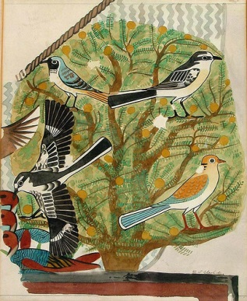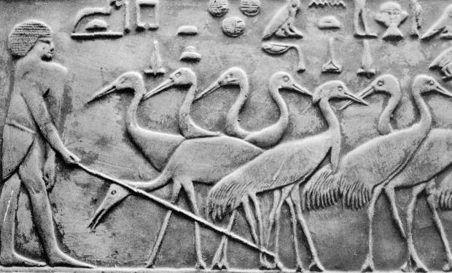
Along the Nile bird-life included the falcons, , gooses, cranes, heron, pigeons, vultures, owls and ibises. Many of these birds were kept in sacred flocks by the ancient Egyptians and some individual birds were even elevated to temple animals. Even the souls (ba) of the ancient Egyptians were frequently depicted with the body a bird.
Ibis was a white bird with black grits head, rock and tips of the wing pinions.
Trickster, Recordkeeper, Sage of Ancient Egypt Thoth, Tehuti or Djehuty were the names of ibis in ancient Egyptian, and was known to be the god of wisdom, writing, speech, measurement, the moon, and magic. He serves as the vizier (prime minister) to Re, King of the gods. He's also the gods' official record-keeper. He's Mr. Science, the Answer Man, and divine Secretary-in-Chief.
Thoth, the Egyptian god of wisdom or knowledge was depicted as having the head of an Ibis. The Greeks viewed him as similar to the Greek god Hermes. As Thoth was one of the major Egyptian deities, the Ibis, like the Falcon was very sacred to the ancient Egyptians.
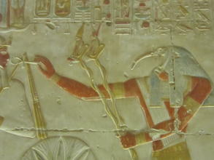

The name "Thoth" seems to be a shorthand version of his name that the Greeks who conquered Egypt found easier to pronounce. Here is Thoth's name in Egyptian hieroglyphs.
He appears in three different forms, sometimes he's an ibis-headed man, sometimes he's a baboon, sometimes he's an ibis. ⁵

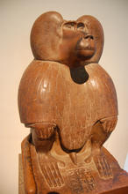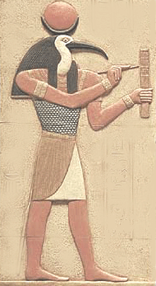

The story goes that at the beginning of spring winged serpents from Arabia fly towards Egypt, and the birds called ibises meet them at the entrance to this country and do not suffer the serpents to go by but kill them
On account of this deed it is (say the Arabians) that the ibis has come to be greatly honored by the Egyptians, and the Egyptians also agree that it is for this reason that they honor these birds. The outward form of the ibis is this:-- it is a deep black all over, and has legs like those of a crane and a very curved beak, and in size it is about equal to a rail: this is the appearance of the black kind which fight with the serpents, but of those which most crowd round men's feet (for there are two several kinds of ibises) the head is bare and also the whole of the throat, and it is white in feathering except the head and neck and the extremities of the wings and the rump (in all these parts of which I have spoken it is a deep black), while in legs and in the form of the head it resembles the other.
Concerning the ibis, this bird had eaten from the divine body (i.e. of Osiris) in the water. Horus sailed on the river far from the great evil deed. The moon had been caused to enter the heavens (become invisible) by (the magic of) a wretched Nubian who was in the Southland. This bird ate from him in the water. It rested on its belly after being sated. Its heart weighed heavy upon it. ⁶
One says about it "ibis" (because it had penetrated the corpse of Osiris with its bill, when it landed in the Great Sea of Flames. One also says about its [Crested Ibis].Of the heart, because it had eaten the relic of the venerable corpse in Nun. Whosoever shall kill an ibis or a hawk, whether it is with his will or against his will, must die⁷.
The shrewmice however and the hawks they carry away to the city of Buto, and the ibises to Hermopolis
Three species of ibis were found in Egypt, the white bodied Sacred Ibis, Ibis religiosa (Threskiornis aethiopicus), with a black head, neck and black wing feather tips, the Glossy Ibis, Ibis comata (Plegadis falcinellus) with dark iridescent plumage and the Hermit Ibis seldom depicted in ancient times.

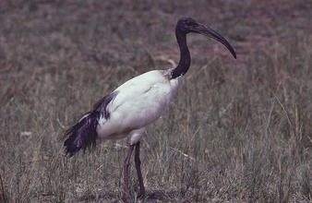

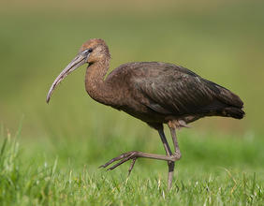

The Sacred Ibis was an object of religious veneration in ancient Egypt, particularly associated with the god, Thoth. At the town of Hermopolis, ibises were reared specifically for sacrificial purposes and in the Serapeum at Saqqara, archaeologists found the mummies of one and a half million ibises ⁸
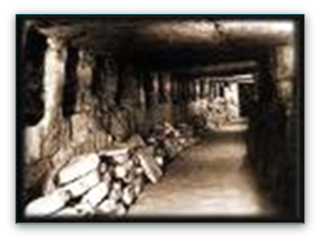
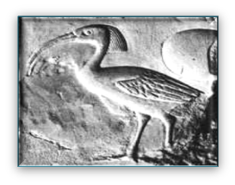
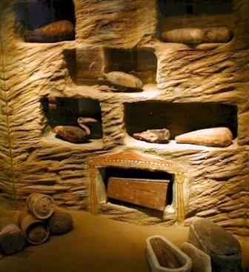
Sacred ibises were mummified during the Late Period and Ptolemaic times, and buried in large numbers in different catacombs through Egypt.⁹ There were three types of ibis in Egypt - the sacred ibis, the hermit ibis and the glossy ibis. The hermit ibis is not a waterside bird, so it is depicted less frequently than the other two birds that were common along the banks of the Nile.
Mummification of the ibis included desiccation and evisceration. Usually, the head and neck of the bird were bent backwards and pressed on the body. The body was then dipped in tar and wrapped tightly with linen. The vast number of mummified ibises suggests that this was done in a mass production, as many times the mummies contained only a part of the body. After serving their ritual purposes, the mummified bodies were placed in ceramic pots, coffins or sarcophagi. ⁹

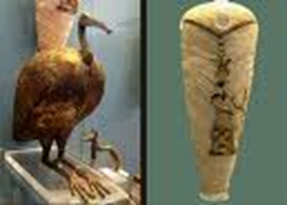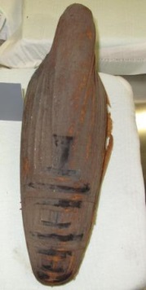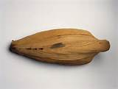

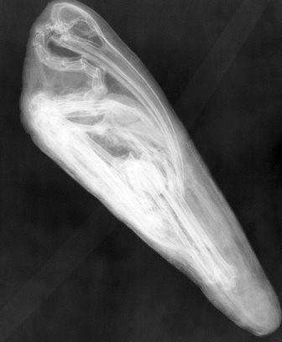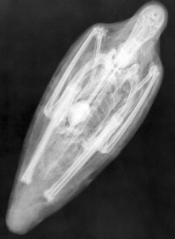

Conservation¹º
The first step in undertaking conservation is to examine an object closely, both with the naked eye and under magnification. Careful examination will often reveal a great deal of detail about the materials and methods used.
Many questions raised during close examination of the piece can only be answered through scientific analysis ¹¹
During the initial examination and study of an object a conservator documents any signs of deterioration. Documentation will include written notes and photography and sometimes also x-radiography.¹²
After a full assessment of the condition of an object has been drawn up, the conservator will propose a course of treatment action.¹³
As with all conservation treatments, materials used in treating the object must not harm any of the original materials used and must be able to be removed at a later date with as little interference with the original materials as possible.¹⁴

Conservation of a severely damaged Ibis mummy¹⁵
The conserved Ibis mummy under study has the GEM No: 32222 & other: 1262

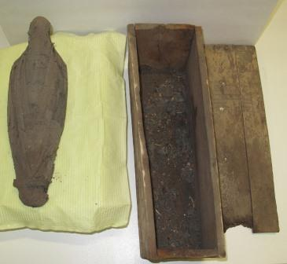

The conserved sample presented in this article is in the Mummies and Human remains Lab in the Grand Egyptian Museum Conservation center where conservation work is being done for the artifacts which will be exhibited when the Museum opens in 2018, the conserved sample here is a Mummy of an Ibis bird wrapped in linen having the number (GEM 32222 other 1262) dated from the late period and was originally found in Minya middle of Egypt.
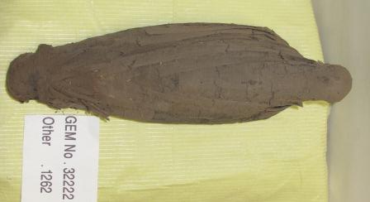

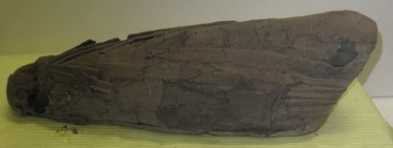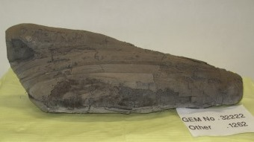

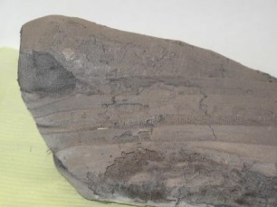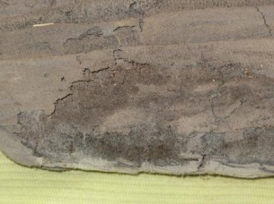
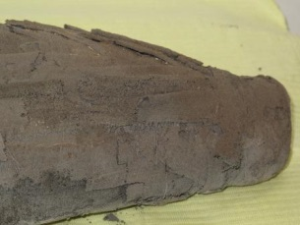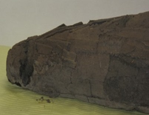

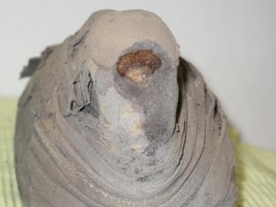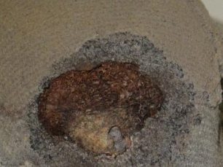

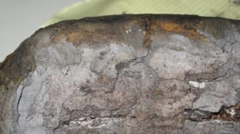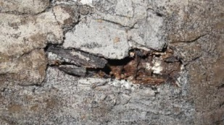
The mentioned conserved and studied mummy was generally in a very bad condition where the outer textile wrapping suffered degradation, dryness, fray, missing parts, missing layers, dust, insect infection , fungal infection, darkness, stains, tear , separated parts, black Resin Remains, deformation, pits and fragility thus the kind of weave of the textile wrapping is a simple plain weave 1:1. ¹³
The body of the ibis mummy was suffering from deterioration& degradation and this includes broken bones.¹⁴
Research and readings has been done to reach to the most suitable techniques and materials needed to execute the conservation work thus maintaining the stability of the optimum suitable needed environmental conditions of temperature and relative humidity always¹⁵.
The Ibis mummy under conservation was well investigated, sterilized then documented by photography, hand drawing including a damage map& and was measured precisely, it has also been examined by stereomicroscope.¹⁶
A plan was made concerning the treatment proposal & suggested conservation and restoration processes needed for the mummy as well as performing needed analysis assisting the conservation process, and the plan was executed as follows:
-Microbiology culture¹⁷ was made by taking 2 swaps from the mummy to investigate kind of available fungal infection thus helping the disinfection process and elimination of present or suspected fungal growth leading to correct treatment.

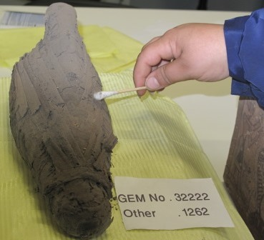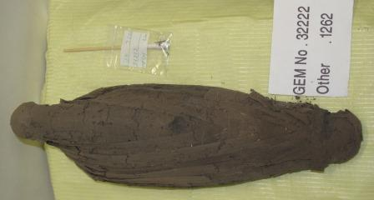

The microbiology swap culture revealed the presence Aspergillus fumigates, Alternaria alternata & Fusarium sp. and was treated by the use of absolute Ethyl Alcohol.

Magnification 5x 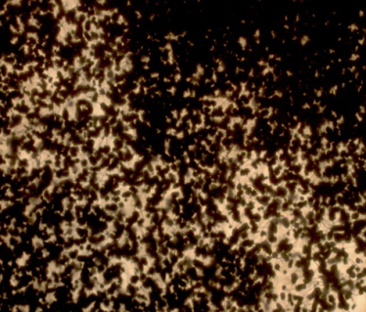 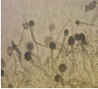 Magnification 40x
Aspergillus fumigatus

Magnification 5x 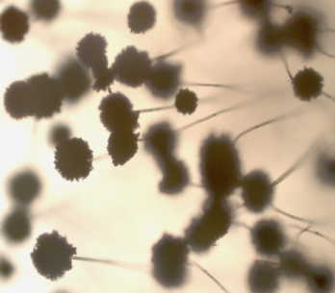 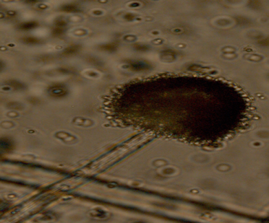 Magnification 40x
Aspergillus niger

-A mimute sample was taken and examined by Scanning Electron Microscope SEM and the results proved the complete deterioration of Lenin wrapping.

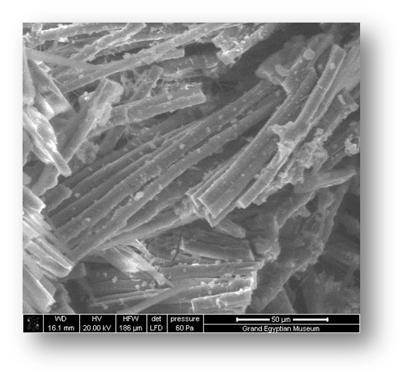
Totally deteriorated Lenin threads

- Sterilization & dissinfection. ¹⁸

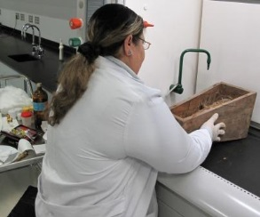
- Simple dust cleaning using delicate pumps.

- Further cleaning by the use of wet cotton swaps with Ethyl alcohol and disteled water 1:1.

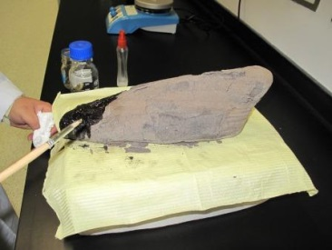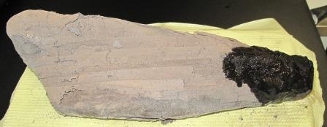

- Fixing the loose parts of the linen wrappings

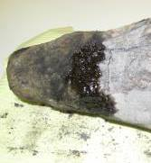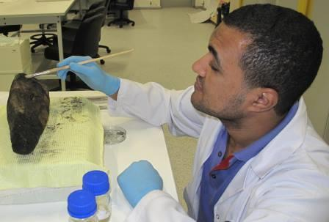

- Consolidation [18]

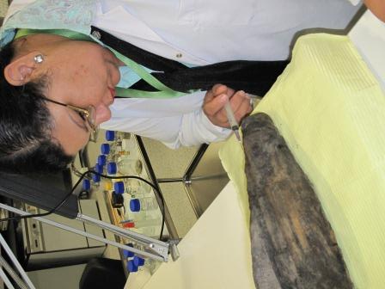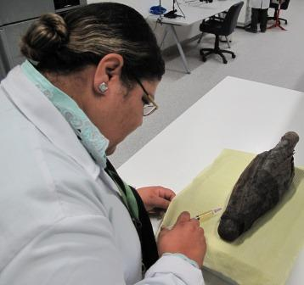

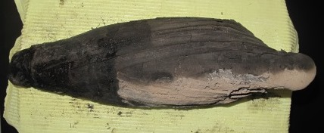

The conservation was completed and the mission was well accomplished and here how the damaged ibis mummy looks after a long time of working patiently.

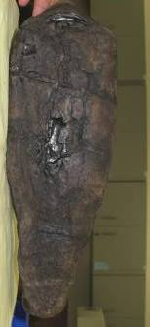
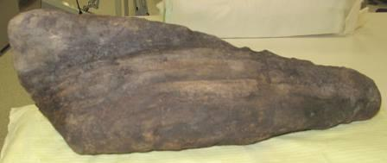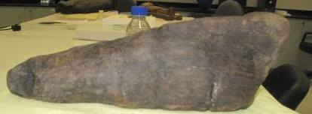

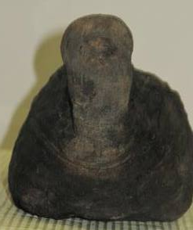
conclusion
In conclusion dealing with mummies conservation is a field that needs a lot of patience, hard delicate work and a lot of research in various fields such as science, history, use of modern technology etc.,. And at the same time quick interference with minimum amounts of chemicals, taking in consideration the importance of reversibility of used materials, and all that should be in well maintained stable, suitable and optimum environmental conditions thus maintaining mummies in the best forms that will last ages for generations to come honoring their great heritage

Before Conservation
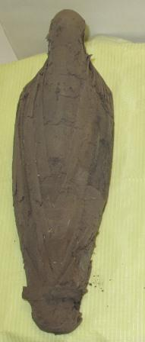

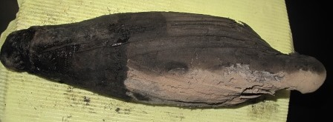 During Conservation 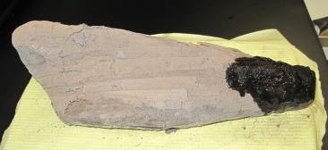

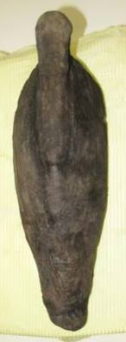
After Conservation

Refrences
1-"Birds of Egypt, the complete checklist". WICE (World Institute for Conservation and Environment).
2-Wikipedia, the free encyclopedia
3- Encyclopedia Britannica
4- Clements, James F. (2000). Birds of the World: a Checklist. Cornell University Press. ISBN 0-934797-16-1.
5- Christian Science Monitor, Archaeologists unearth statue of Egyptian god “Thoth”, 16 March 2010
6-Journal of Archaeological Science
7- Clark, R. & Rundle, T., (1978), Myth and Symbol in Ancient Egypt, Thames and Hudson, 1991
8-Ikram, S., (2012), “An Eternal Aviary, Bird Mummies from Ancient Egypt”, in Rozenne Bailleul Le-Suer (ed), Between Heaven and Earth: Birds in Ancient Egypt, The Oriental Institute of the University of Chicago
9- Mr. Pearson’s Account of two Mummies of the Egyptian Ibis by John Pearson Read June 13, 1805
10-.Conservation A Collaboration between Art and Science RAIFAH M. KABBANI Pace University Department of Chemistry and Physical Sciences New York, NY 10038
11- Dorji, Kinley.2005. A new way to preserve textiles. Kuensel, Bhutan, December 17,-2005
12- Carson, V (1989). ‘Preventive Textile Conservation’ AGNANZ Journal Volume 20 April 1989.
13- Brooklyn museum, British Museum and other Museums throughout the world (conservation of the collections).
14- Nicola, G.L. Et Al. Conservation of Mummies and Sarcophagi. 2008
15- A. E. David, “Conservation of mummified Egyptian Remains”, in A. R. David (ed.), in Science in Egyptology: proceedings of the Science in Egyptology Symposia, Manchester University Press, Manchester, 1986.
16- Burke, John. 1999. Anoxic Microclimates: A Treatment for Pest Control” Conserve O
Gram, 3(9).
17-Conservation Science Heritage Materials ISBN-10: 0-85404-659-3
18- Hercules, Inc. Klucel, Hydroxypropyl Cellulose Chemical and Physical Properties.
Wilmington, DE: Hercules Inc., 1982

